**PRACTICAL NO:-3**

1. **Create a simple web page with various server controls to demonstrate setting and use of their properties. (Example : AutoPostBack)**

First we set the property autopostback: True to all the controllers. It reload pages when these events occur.

**CODE:-**

using System;

using System.Collections.Generic;

using System.Linq;

using System.Web;

using System.Web.UI;

using System.Web.UI.WebControls;

namespace practical_some_first

{

public partial class autopostback : System.Web.UI.Page

{

protected void Page_Load(object sender, EventArgs e)

{

}

protected void TextBox1_TextChanged(object sender, EventArgs e)

{

Label1.Text = TextBox1.Text;

}

protected void DropDownList1_SelectedIndexChanged(object sender, EventArgs e)

{

try

{

int a = DropDownList1.SelectedIndex;

if (a == 0)

{

Label1.ForeColor = System.Drawing.Color.Red;

}

else if (a == 1)

{

Label1.ForeColor = System.Drawing.Color.Blue;

}

else if (a == 2)

{

Label1.ForeColor = System.Drawing.Color.Green;

}

else

{

Label1.ForeColor = System.Drawing.Color.Black;

}

}

catch {}

}

protected void CheckBoxList1_SelectedIndexChanged(object sender, EventArgs e)

{

try

{

int a = CheckBoxList1.SelectedIndex;

if (a == 0)

{

Label1.BackColor = System.Drawing.Color.Green;

}

else if (a == 1)

{

Label1.BackColor = System.Drawing.Color.Yellow;

}

else if (a == 2)

{

Label1.BackColor = System.Drawing.Color.Blue;

}

else

{

Label1.BackColor = System.Drawing.Color.Red;

}

}

catch { }

}

protected void TextBox1_TextChanged1(object sender, EventArgs e)

{

Label1.Text=TextBox1.Text;

}

}

}

OUTPUT:-

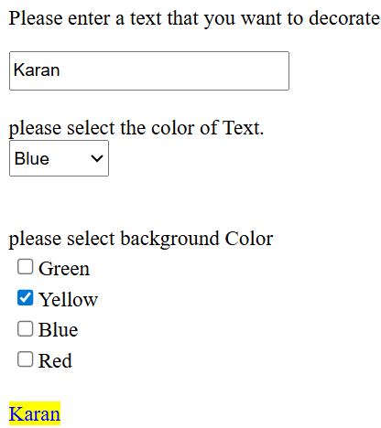

**b. Create a simple application to demonstrate your vacation using calendar control.**

Here we first drag and drop calendar, that is reach controller.

Then we **double click** it’s attribute of the **Day_Render.**

We now able to render the date based on the function.

**CODE:-**

protected void Calendar1_DayRender(object sender, DayRenderEventArgs e)

{

Dictionary<DateTime, string> dict = new Dictionary<DateTime, string>();

DateTime d1 = Convert.ToDateTime("14-07-2025 00:00:00");

dict.Add(d1, "Sarsoli Dham");

DateTime d2 = Convert.ToDateTime("18-07-2025 00:00:00");

dict.Add(d2, "Abhishek's home");

DateTime d3 = Convert.ToDateTime("20-07-2025 00:00:00");

dict.Add(d3, "Amboli");

DateTime d4 = Convert.ToDateTime("26-07-2025 00:00:00");

dict.Add(d4, "Freshers' party");

DateTime d5 = Convert.ToDateTime("27-07-2025 00:00:00");

dict.Add(d5, "Savdav waterfall");

foreach (DateTime x in dict.Keys)

{

if (x.Equals(e.Day.Date.Date))

{ Label l = new Label();

l.Text = "<Br>"+dict[x]+"<br>";

l.ForeColor = System.Drawing.Color.Red;

l.BorderColor = System.Drawing.Color.AliceBlue;

e.Cell.Controls.Add(l);

}

**OUTPUT:-**

